**MODULE END EXAM LINUX&CLOUD**

**CLOUD SECTION**

**Q1) Create a linux EC2 And access the ec2 through putty on your system convert this .pem file tp .ppk file and then create a html page and make it available on a public ip address?**

**\*Launch/create the instance**

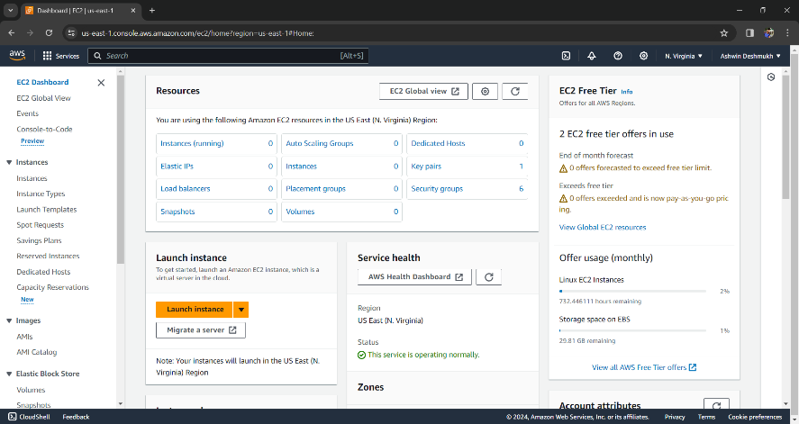



**\*give name to it**

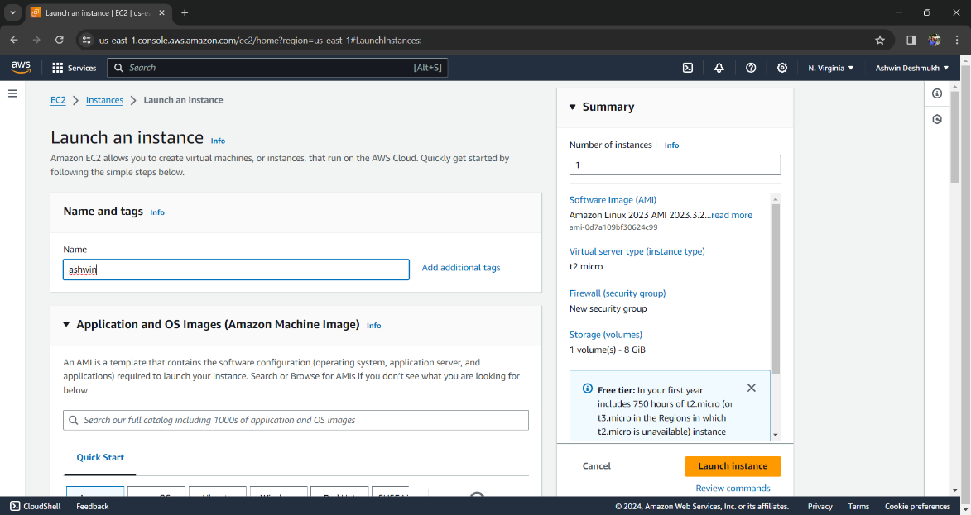



\***create a key pair**

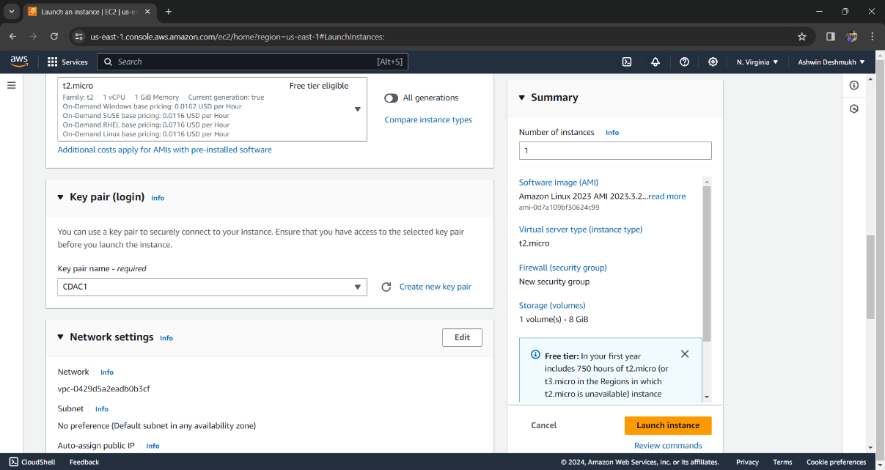

**\*Allow this permisssions and click on launch instances**

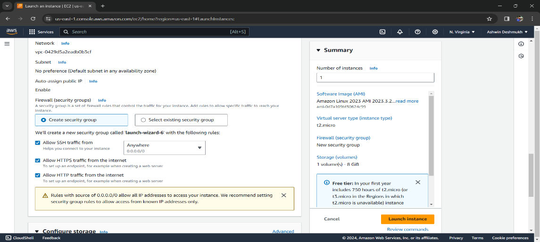

\***COPY THE PUBLIC ADDRESS**

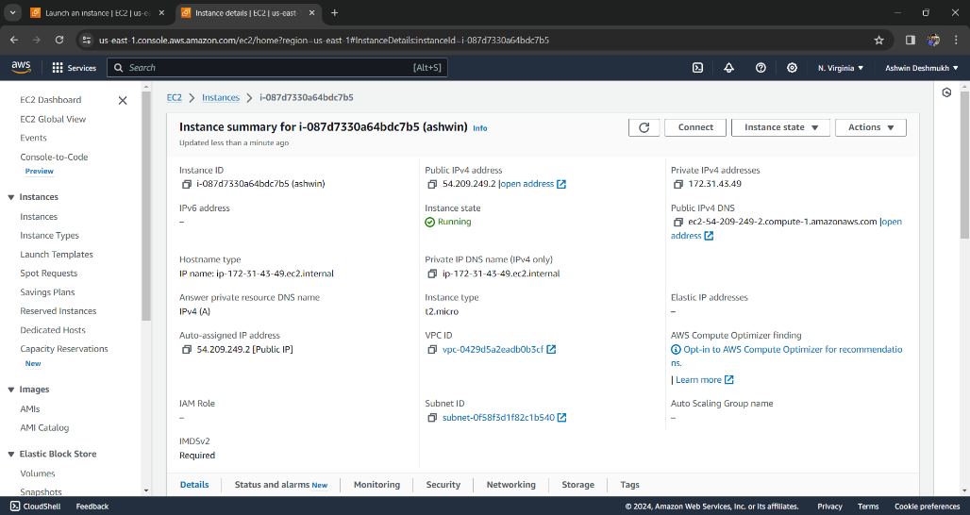



**\*OPEN THE PUTTY ENTER THE HOST NAME AND PRESS THE FOLLOWLING COMMANDS**

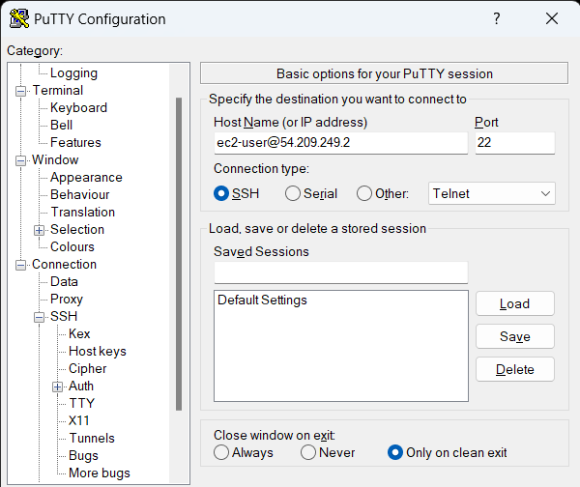



**\*SELECT PRIVAIT KEY**

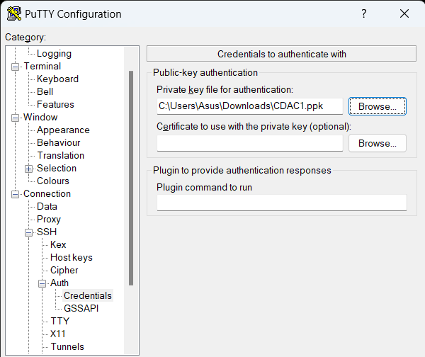



**\*COMMANDS TO EXICUTE IN PUTTY TERMINAL**

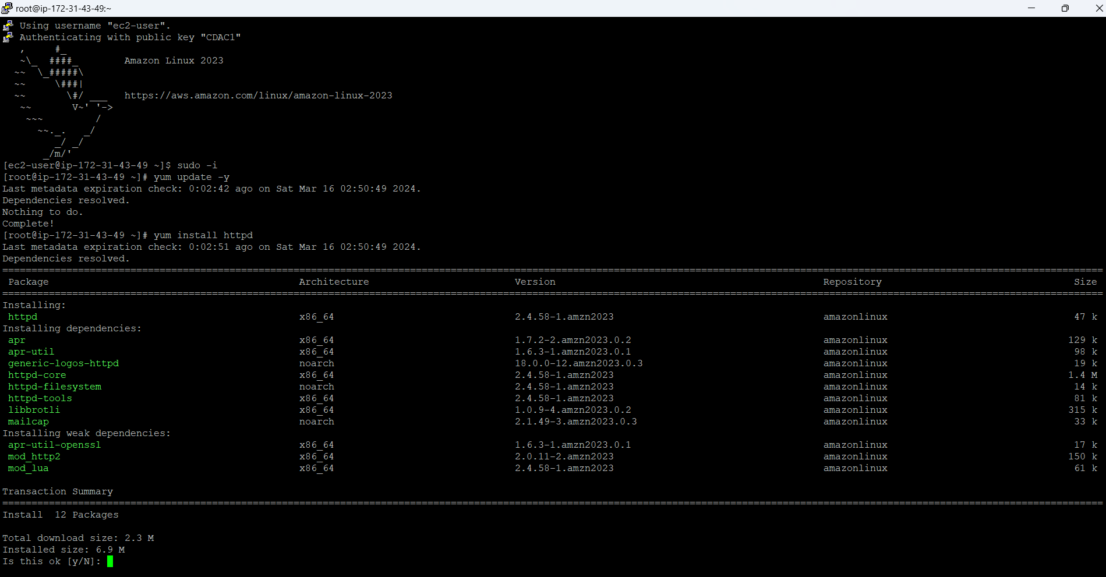

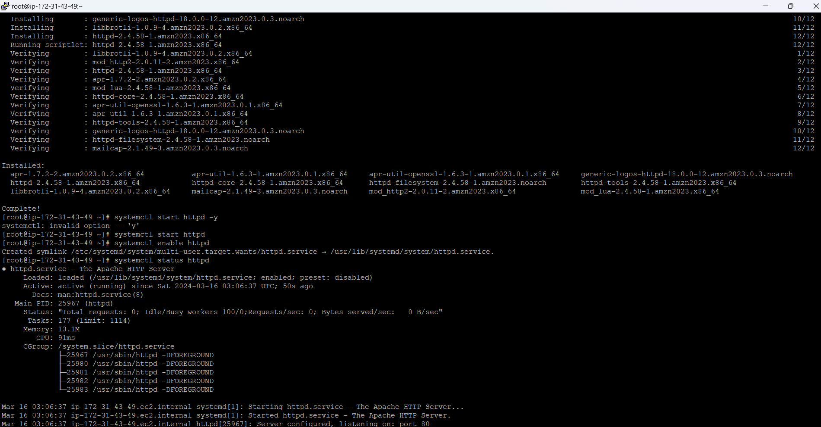

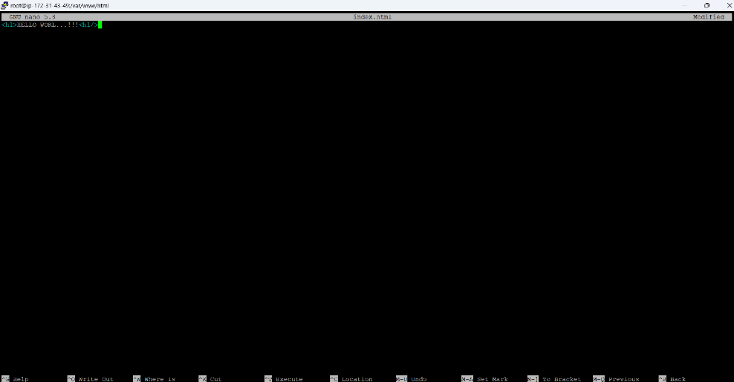

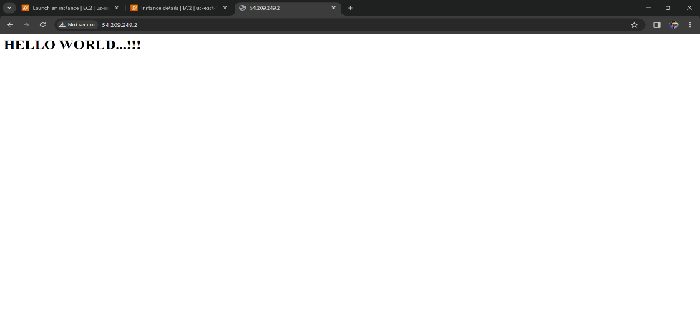

**Q2)CREATE S3 BUCKET AND UPLOAD A FEW FILES AND GIVE THEM PUBLIC ACCES SO THAT IT CAN BE ASSESED THROUGH OBJECT URL?**



**\*CREATE BUCKET**

**\***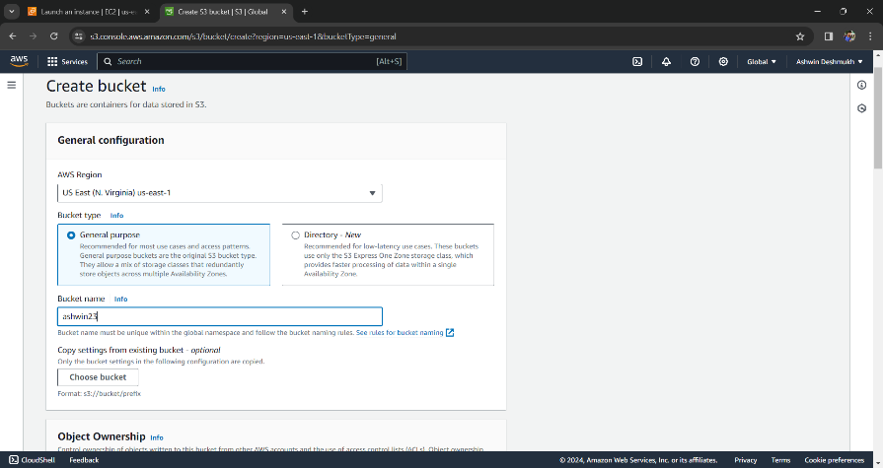



**\*SELECT ON CREATED BUCKET**

**\***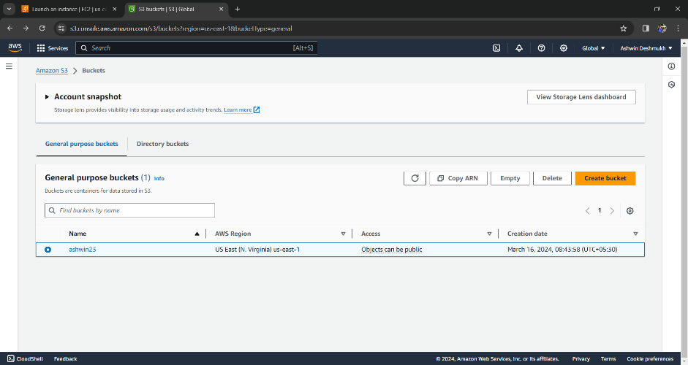



**\*UPLOAD A IMAGE**

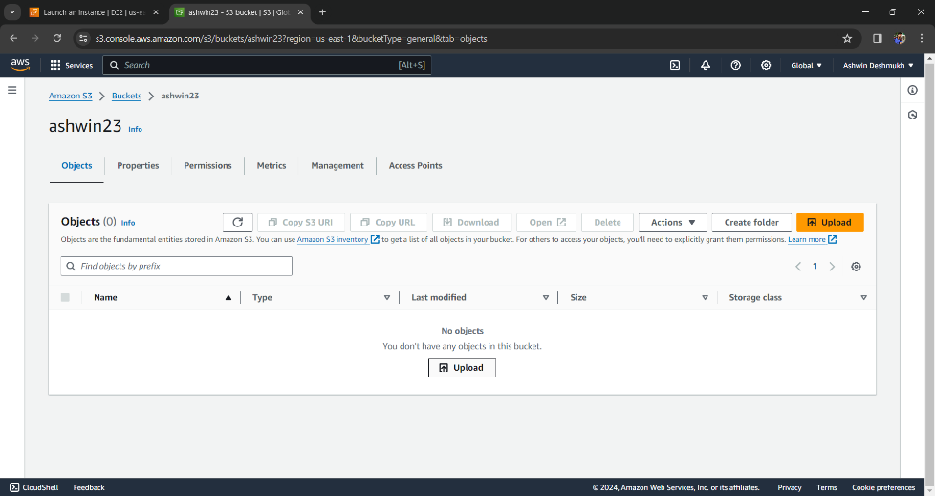



**\*ADD IMAGE FILE AND UPLOAD**



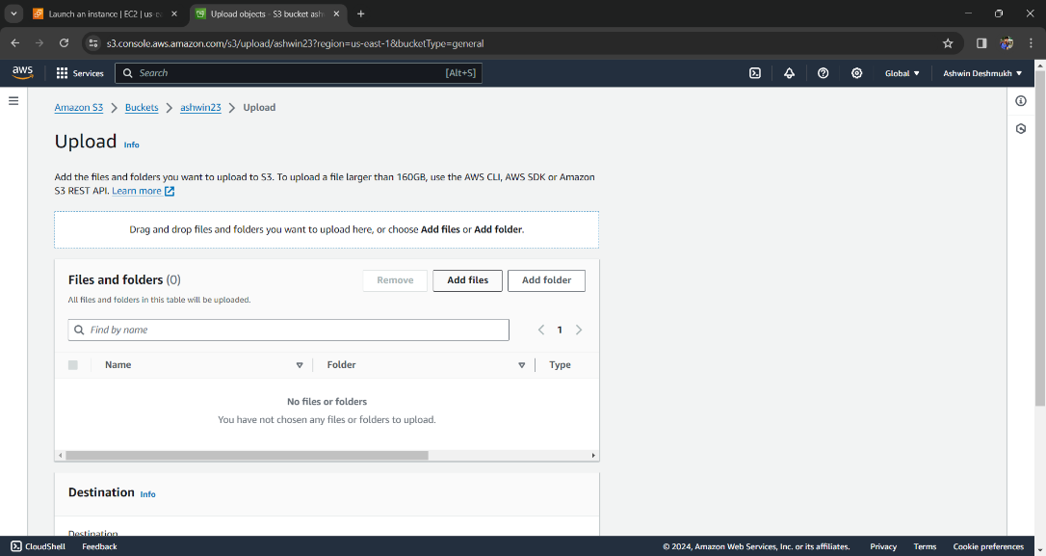



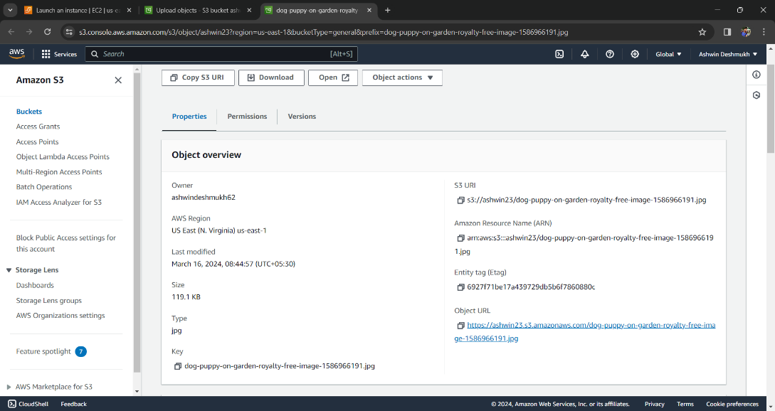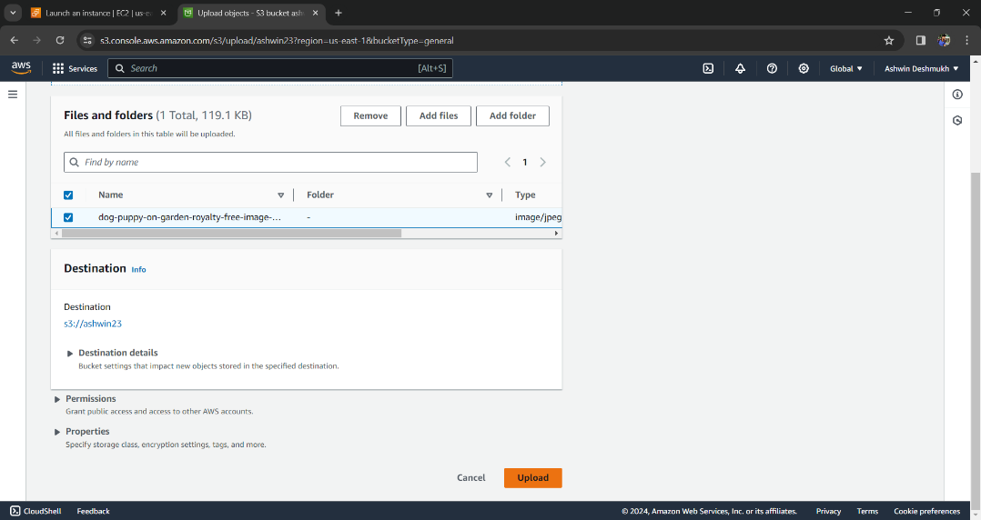

**\*CLICK ON THE LINK**

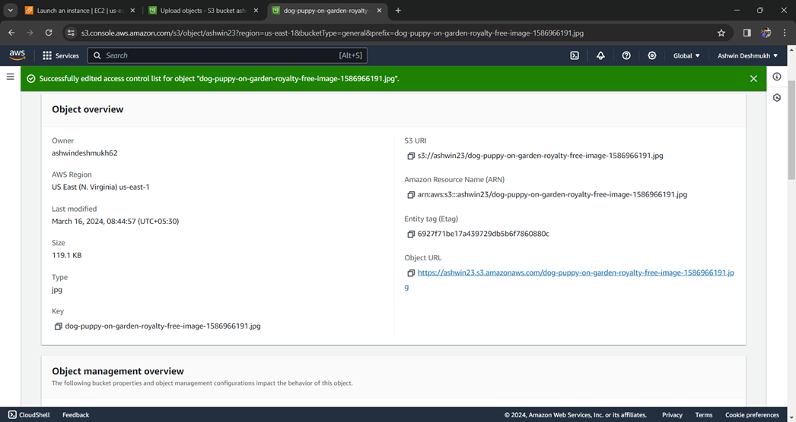



**\*TO MAKE THE ULR PUBLIC WE HAVE TO MAKE THE CHANGES**

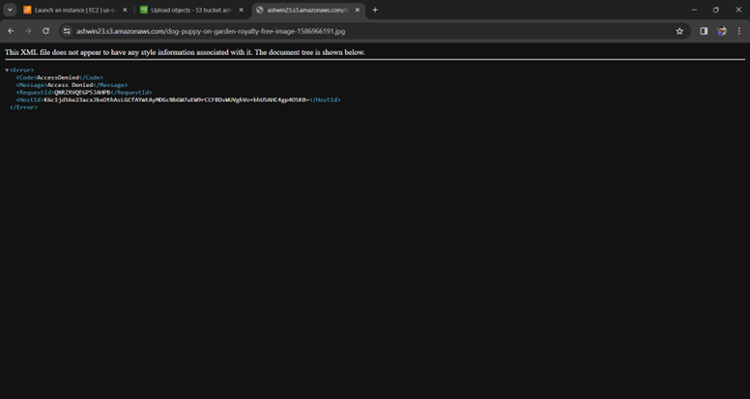

**\*CLICK ON EDIT**

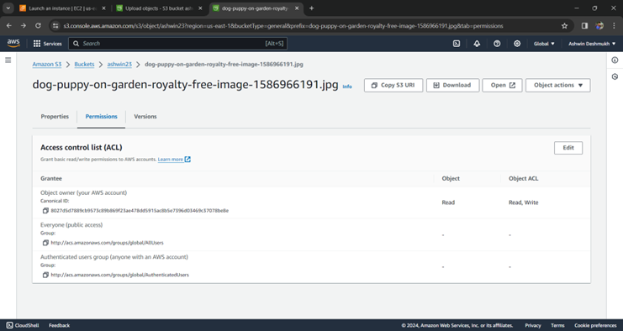

*ALLOW THE BOXES

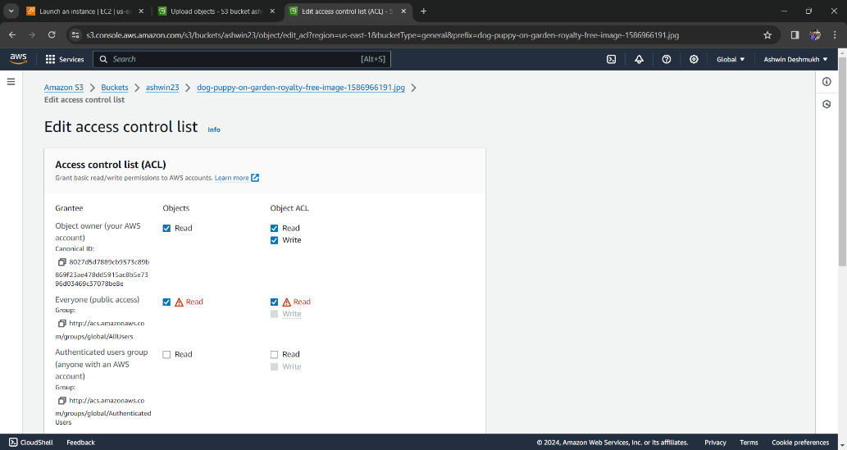

**\*LICK ON THE URL AND COPY TO VIEW IMAGE**

https://ashwin23.s3.amazonaws.com/dog-puppy-on-garden-royalty-free-image-1586966191.jpg

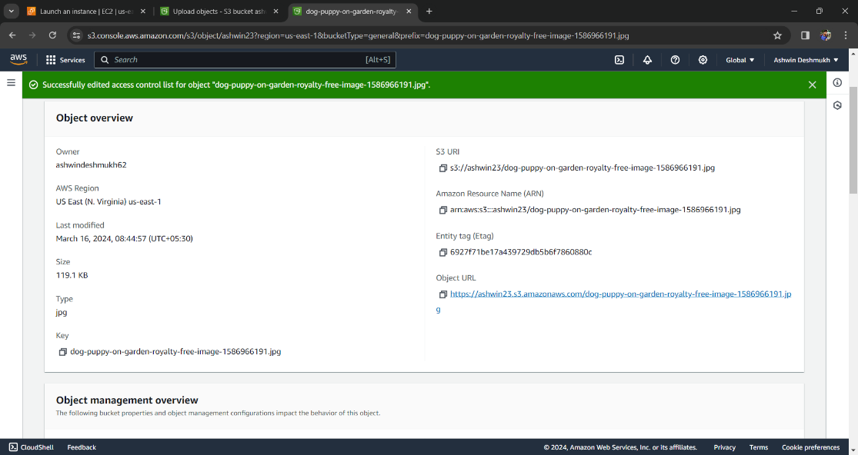

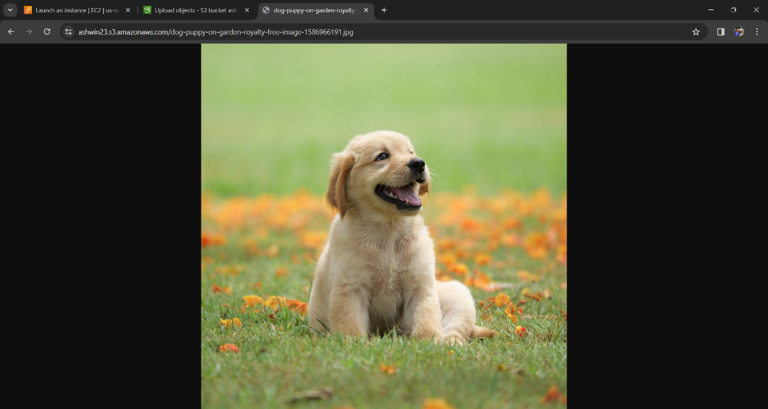

**LINUX**

**Q2)** Write a shell script to display a menu like “1. Date, 2. Cal, 3. Ls, 4. Pwd, 5. Exit” and execute the commands depending on user choice

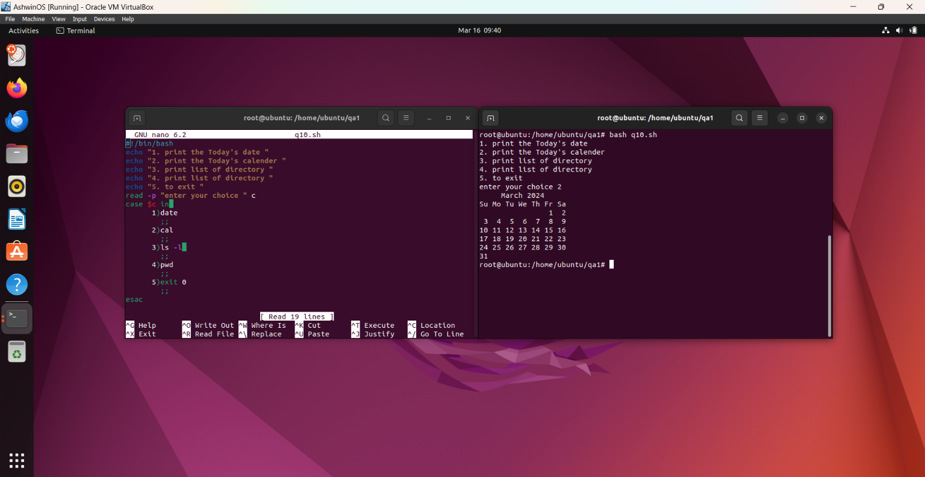

**Q3. Write a Linux directory and file management script that allows the user to perform the**

**following actions**

**● Create a new directory with a specified name.**

**● Rename an existing directory with a new name.**

**● Move an existing directory to a new location.**

**● Delete an existing directory.**

**● Create a new file in a specified directory.**

**● Delete an existing file in a specified directory with a specified name**